Module 7(Introduction to array)

What will we learn:

1. Learn about array
2. Why array is necessary
3. How array is saved in memory and how to access it
4. How to take input and give output of an array
5. How to print an array reversely
6. Determine Array’s all value’s sum

7-1:

Syntax:

data_type name[size]

7-3:

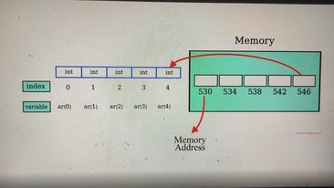

7-7(initializing an array):

Most important thing among all lessons in this chapter is

int array[n] = {0}; // initing an array with zero!